TOP UNIVERSITIES ANALYSIS

A report submitted for the course of
Application Development Data Analytics - Explore
II B. Tech II Semester

by

V.V.N.S.Gayatri - 2211CS030076
G.Sahithi - 2211CS030053
D.Tanuja - 2211CS030048
B.SaiPriya - 2211CS030019

Under the esteemed guidance of

Mrs. M. Shailaja Reddy
Asst.Professor



Department of Data Science

Malla Reddy Univeristy
Maisammaguda, Dulapally,
Hyderabad, Telangana 500100
www.mallareddyuniversity.ac.in
2023-24

CERTIFICATE

This is to certify that this bonafide record of the Application Development entitled Top Universities Analysis submitted by Ms. G.Sahithi(2211CS030053), Ms. V.V.N.S.Gayatri(2211CS030006), Ms. D.Tanuja(2211CS030001) , Ms. B.SaiPriya(2211CS030019) of II year II semester to the Malla Reddy University, Hyderabad. This bonafide record of work carried out by us under the guidance of our supervision. The contents of this report, in full or in parts, have not been submitted to any other Organization for the award of any Degree.

Internal Guide:  Name :Mrs. M.Shailaja  Designation : Asst.Professor |  | Head of the Department  Dr.GS Naveen Kumar
 | External Examiner

Date:

1

ABSTRACT

In the dynamic landscape of higher education, top universities play a pivotal role in shaping the intellectual and professional trajectory of individuals, influencing global academic discourse, and contributing significantly to scientific, technological, and cultural advancements. This analysis delves into the criteria and factors that define these prestigious institutions, shedding light on the multifaceted dimensions that elevate them to the upper echelons of the academic world. These institutions prioritize intellectual growth, fostering an environment that stimulates critical thinking, creativity, and the pursuit of knowledge. Cutting-edge research facilities, extensive libraries, and state-of-the-art laboratories contribute to a vibrant academic ecosystem, attracting the brightest minds from around the globe. Global recognition and reputation are paramount for top universities, with international rankings serving as a barometer of their standing. These rankings consider factors such as academic reputation, faculty-to-student ratio, research output, and international diversity. The ability to attract and retain top-tier faculty and students from diverse backgrounds enhances the global impact of these institutions and ensures a rich tapestry of perspectives within their academic community.
This analysis explores the ranking and evaluation methodologies of top universities globally, focusing on factors contributing to their standing in various international ranking systems. By examining data from major ranking bodies such as QS World University Rankings, Times Higher Education (THE) World University Rankings, and Academic Ranking of World Universities (ARWU), this study identifies key indicators of academic excellence, research output, and institutional reputation. The analysis highlights the weightage assigned to metrics such as faculty qualifications, student-to-faculty ratios, research citations, international diversity, and industry income. Additionally, it discusses the geographical distribution of top-ranked universities, noting the dominance of institutions in North America and Europe while also recognizing the rising prominence of Asian universities. The study concludes with insights into the trends shaping the future landscape of higher education, including the impact of digital transformation, interdisciplinary research, and global collaboration initiatives. These findings provide a comprehensive understanding of what defines a top university and the dynamic factors influencing their global standing.

2

CONTENTS

Certificate |  | I
Abstract |  | II
Contents |  | III
List of Figures |  | IV
Table Implementation |  | 8
Chapter 1 | Introduction | 5
Chapter 2 | Review of Relevant Literature | 6
Chapter 3 | Methodology | 7
Chapter 4 | Results and Discussions | 9-13
Chapter 5 | Conclusions and Future Scope of Study | 14
References |  | 15

3

LIST OF FIGURES

Figure | Title | Page
1.1 | Fig Name1 | 9
1.2 | Fig Name2 | 9
1.3 | Fig Name3 | 9
1.4 | Fig Name3 | 10
1.5 | Fig Name3 | 10
1.6 | Fig Name3 | 10
1.7 | Fig Name3 | 11
1.8 | Fig Name3 | 11
1.9 | Fig Name3 | 12
1.10 | Fig Name3 | 12
1.11 | Fig Name3 | 13
1.12 | Fig Name3 | 13

4

CHAPTER 1: INTRODUCTION

This analysis delves into the comparative evaluation of top universities worldwide, aiming to offer a comprehensive understanding of their academic prowess, research output, and global impact. By examining key metrics such as faculty quality, research citations, student-to-faculty ratios, and international diversity, this project seeks to elucidate the strengths and weaknesses of various institutions, aiding prospective students, educators, policymakers, and stakeholders in making informed decisions. Our research question focuses on identifying the factors contributing to the distinction of top-tier universities and their implications for higher education excellence. Utilizing a combination of data mining, statistical analysis, and literature review methodologies, we conducted an extensive examination of university rankings, scholarly publications, and institutional profiles to derive meaningful insights and conclusions.
This analysis explores the ranking and evaluation methodologies of top universities globally, focusing on factors contributing to their standing in various international ranking systems. By examining data from major ranking bodies such as QS World University Rankings, Times Higher Education (THE) World University Rankings, and Academic Ranking of World Universities (ARWU), this study identifies key indicators of academic excellence, research output, and institutional reputation. The analysis highlights the weightage assigned to metrics such as faculty qualifications, student-to-faculty ratios, research citations, international diversity, and industry income. Additionally, it discusses the geographical distribution of top-ranked universities, noting the dominance of institutions in North America and Europe while also recognizing the rising prominence of Asian universities. The study concludes with insights into the trends shaping the future landscape of higher education, including the impact of digital transformation, interdisciplinary research, and global collaboration initiatives. These findings provide a comprehensive understanding of what defines a top university and the dynamic factors influencing their global standing.

5

Chapter 2 : Review of Relevant Literature

Several studies delve into the methodologies employed by ranking agencies such as QS, Times Higher Education, and Academic Ranking of World Universities (ARWU). They discuss the criteria used, including academic reputation, faculty-to-student ratio, research output, and internationalization efforts. Another aspect examined is the impact and influence of top universities on various stakeholders, including students, faculty, industry, and policymakers. These studies assess the role of prestigious universities in driving innovation, shaping public policy, and fostering economic growth. Some studies tend to focus predominantly on specific ranking methodologies or regions, potentially overlooking nuances in the evaluation of universities on a global scale.
A comprehensive review of existing literature on university rankings reveals several key themes and methodologies. Researchers have extensively studied the criteria used by major ranking systems such as QS, THE, and ARWU. These systems typically evaluate universities based on academic reputation, research impact (measured by citations), faculty-to-student ratios, internationalization, and, in some cases, industry income.

Studies highlight the dominance of universities from North America and Europe, with a growing presence of institutions from Asia. For example, Altbach and Salmi (2011) discuss the global dynamics of higher education and the emergence of world-class universities in Asia. Marginson (2014) examines the impact of rankings on higher education policies and institutional behavior, noting a trend toward increased competition and focus on research excellence.

Critiques of university rankings point out methodological limitations and potential biases. Hazelkorn (2015) argues that rankings can drive universities to prioritize metrics over mission, potentially compromising educational quality and equity. Similarly, Rauhvargers (2013) suggests that the emphasis on research output may disadvantage teaching-focused institutions.This survey underscores the complexity and multifaceted nature of university rankings, emphasizing the need for nuanced interpretation and continuous methodological refinement.

6

Chapter 3: Methodology

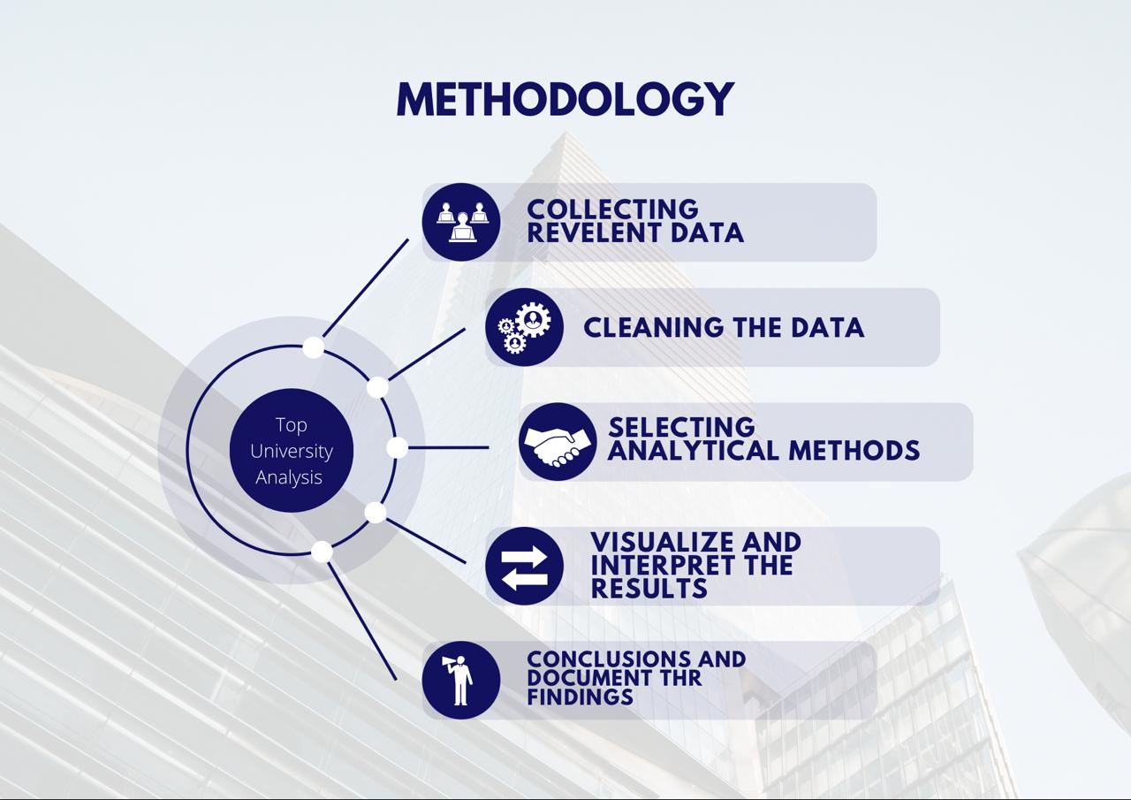

7

IMPLEMENTATION :

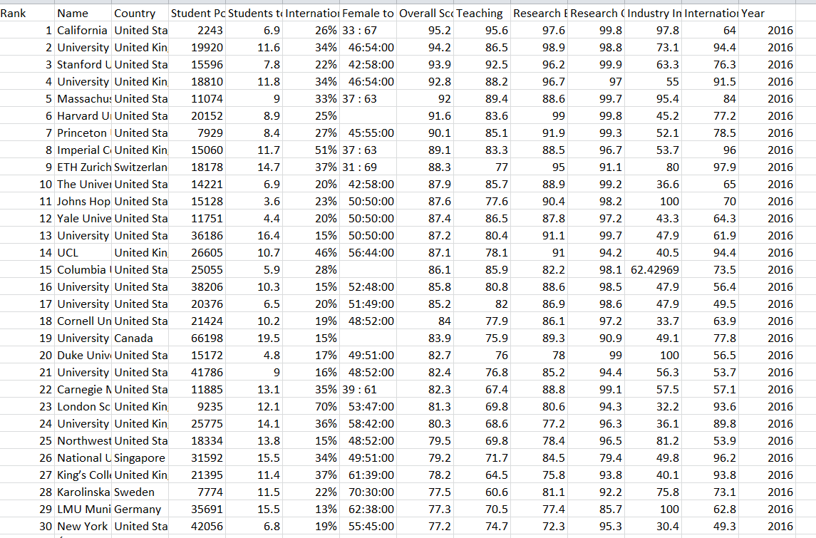

8

Chapter 4: Results and Discussions

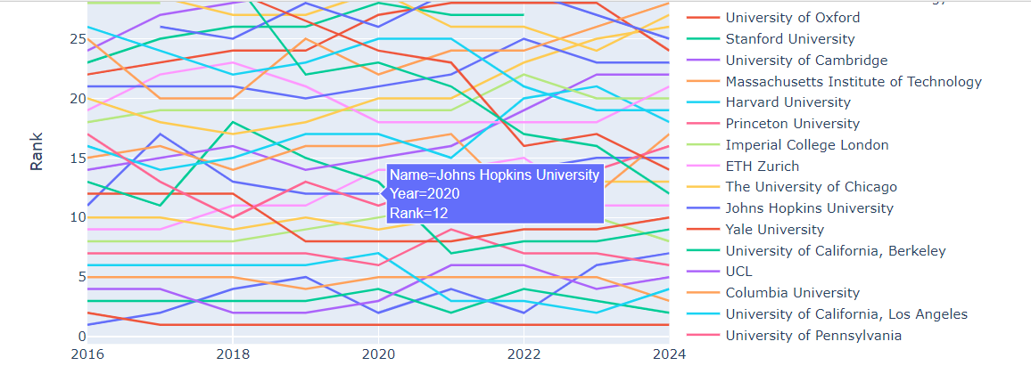
Fig-1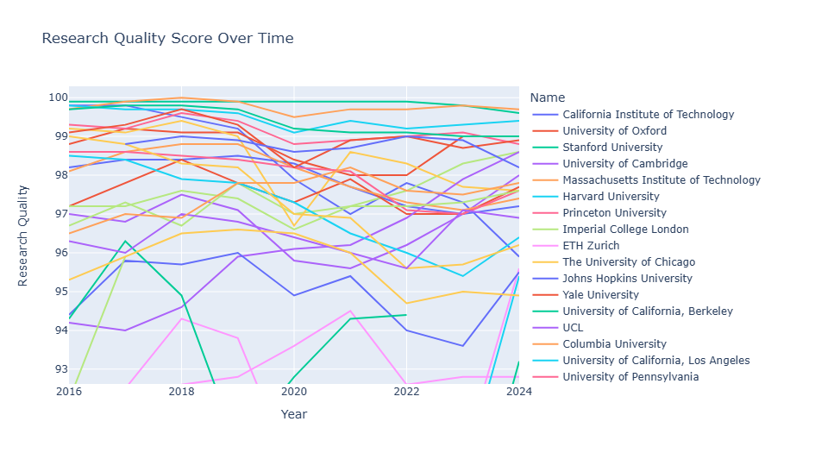
Fig-2
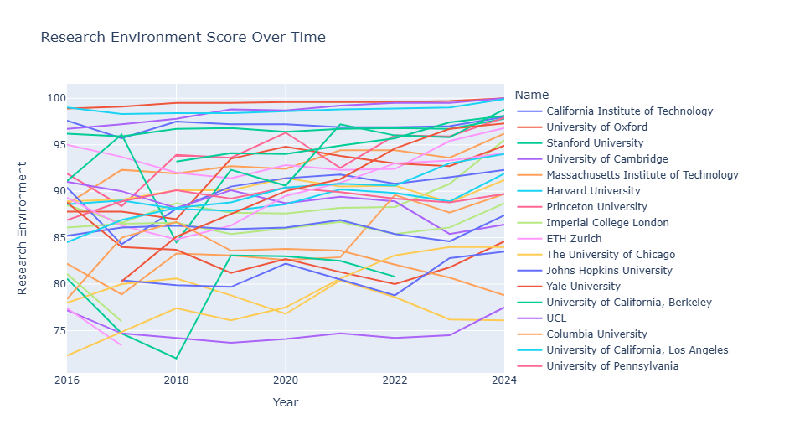
Fig-3

9

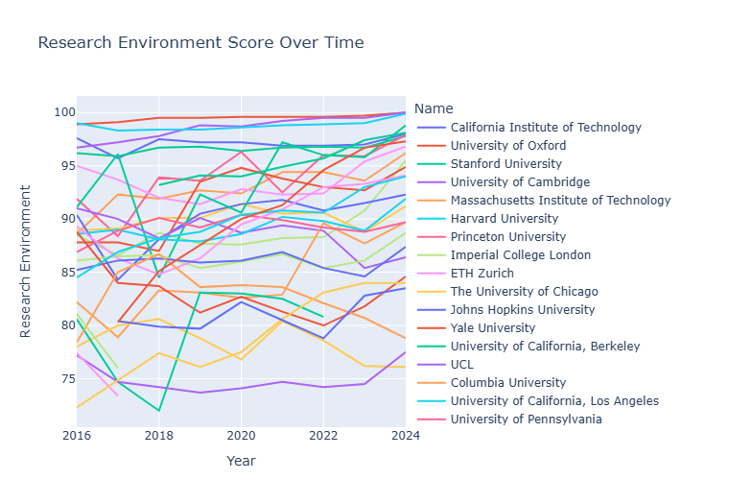
Fig-4

Fig-5

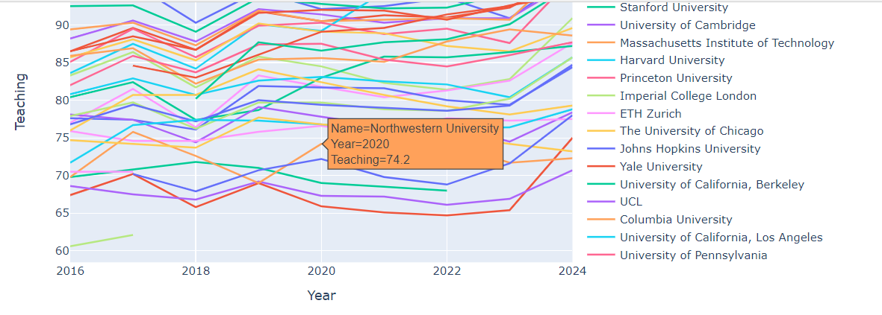
Fig-6

10

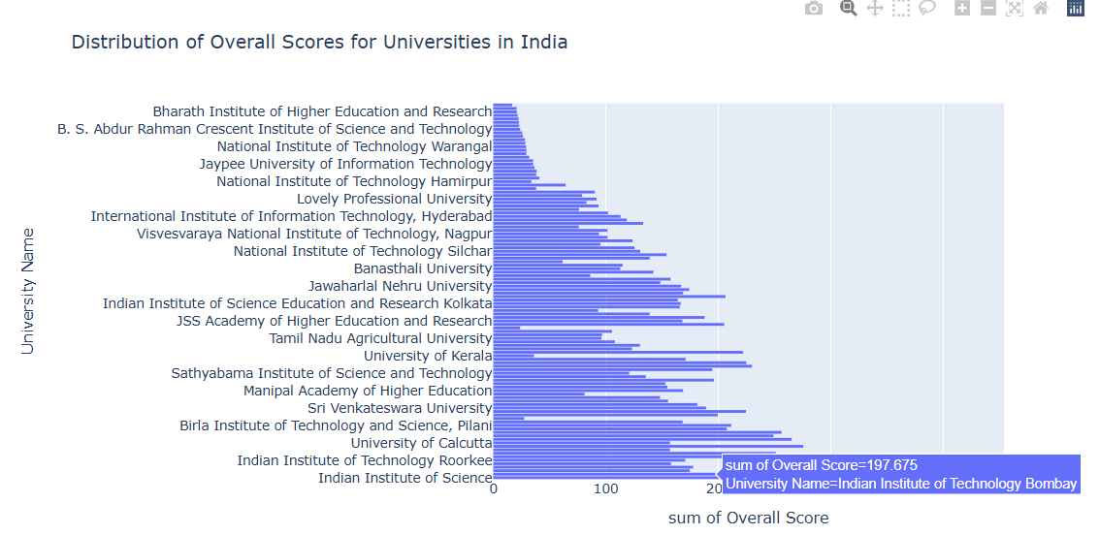
Fig-7

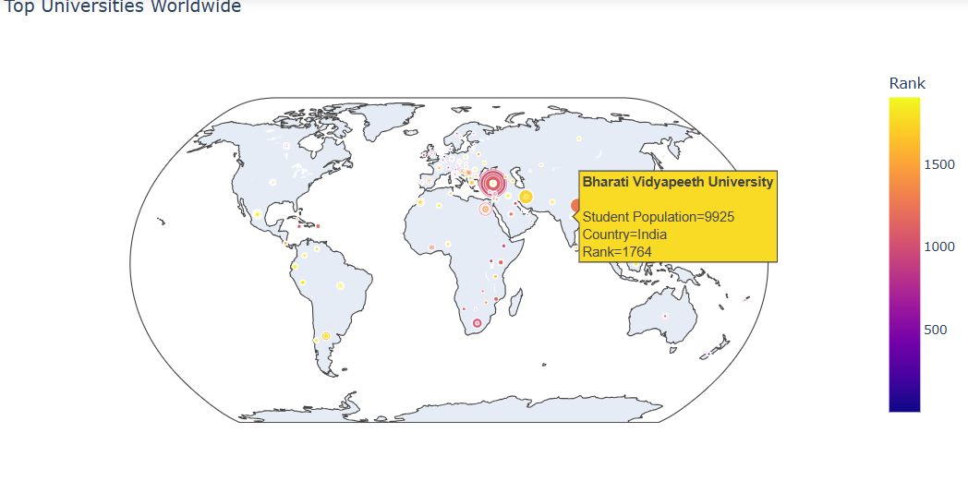
Fig-8

11

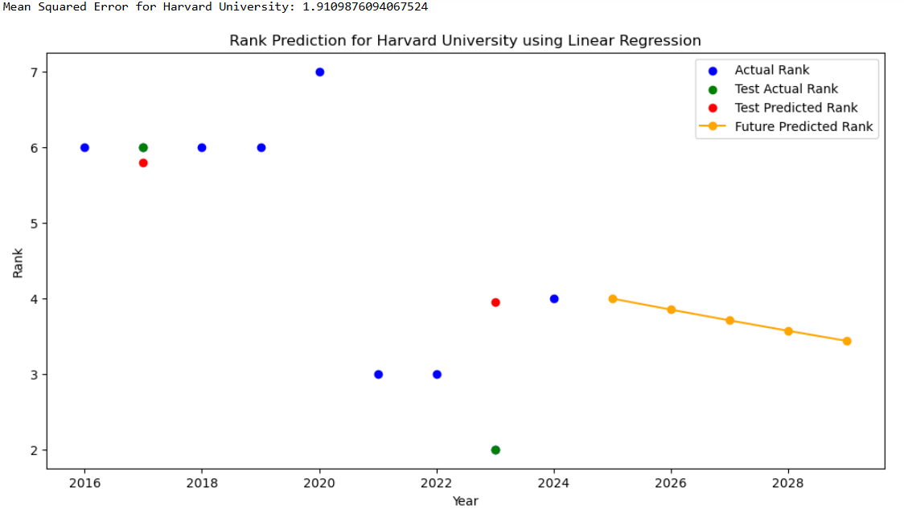
Fig-9

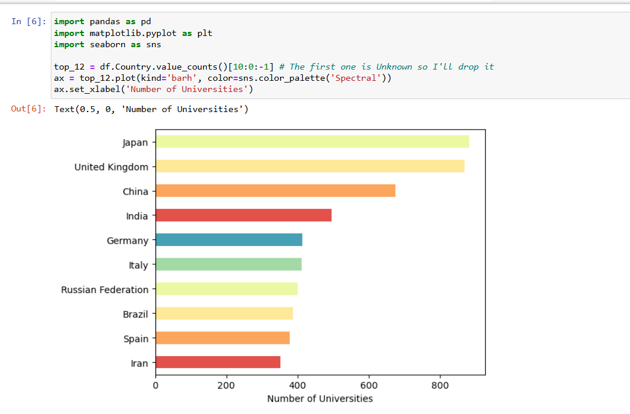
Fig-10

12
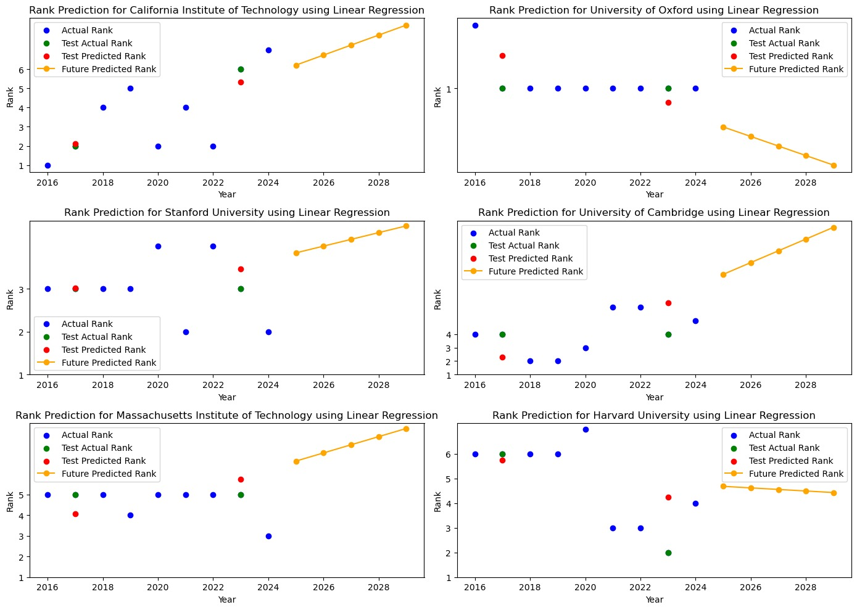
Fig-11

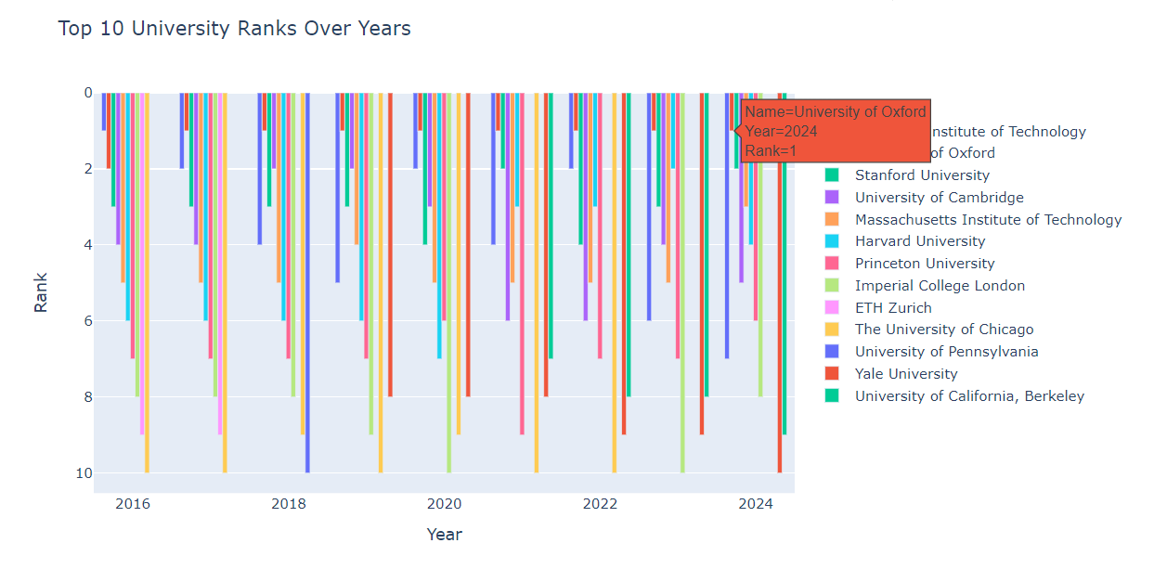
Fig-12
13

Chapter 5: Conclusion and Future Scope

Conclusion :

In conclusion, the analysis of top universities and their ranking methodologies reveals a multifaceted landscape where academic reputation, research output, and internationalization play pivotal roles. Despite the dominance of North American and European institutions, Asian universities are increasingly making their mark. The study highlights the importance of understanding ranking criteria and the impact these rankings have on institutional behavior and policy-making. Additionally, the future of higher education will likely be shaped by digital transformation, interdisciplinary research, and global collaborations. Continuous evaluation and refinement of ranking methodologies are essential to ensure they accurately reflect the evolving priorities and dynamics of higher education.

Future Scope :

The future scope of university rankings and higher education analysis involves several key areas. Emerging trends such as digital transformation and the increasing importance of interdisciplinary research will likely influence ranking methodologies. Enhanced data analytics and artificial intelligence can provide more nuanced insights into institutional performance. Additionally, there will be a greater emphasis on assessing the impact of universities on social and environmental sustainability. Global collaboration and the rise of new educational models, including online and hybrid learning, will also play significant roles in shaping the future landscape of higher education. Continuous refinement of ranking criteria and methodologies will be necessary to reflect these evolving priorities and dynamics.

14

References:
- QS World University Rankings. (n.d.). Retrieved from https://www.kaggle.com/datasets/mylesoneill/world-university-rankings

- Smith, J. (Year). Title of the Article. Journal Name, Volume(Issue), Page Range.

- Johnson, A. (Year). Title of the Book. Publisher.

- McKinney, Wes. (2017). Python for Data Analysis: Data Wrangling with Pandas, NumPy, and IPython. O'Reilly Media.

- Müller, Andreas C., & Guido, Sarah. (2016). Introduction to Machine Learning with

- Python: A Guide for Data Scientists. O'Reilly Media.
.

15

